**KNearest Neighbors Classifier**

**K Nearest Neighbor(KNN) is a very simple, easy to understand, versatile and one of the topmost machine learning algorithms. KNN used in the variety of applications such as finance, healthcare, political science, handwriting detection, image recognition and video recognition.**

**In Credit ratings, financial institutes will predict the credit rating of customers. In loan disbursement, banking institutes will predict whether the loan is safe or risky. In political science, classifying potential voters in two classes will vote or won't vote. KNN algorithm used for both classification and regression problems. KNN algorithm based on feature similarity approach.**

**In KNN, K is the number of nearest neighbors. The number of neighbors is the core deciding factor. K is generally an odd number if the number of classes is 2. When K-1, then the algorithm is known as the nearest neighbor algorithm. This is the simplest case. Suppose P1 is the point, for which label needs to predict. First, you find the one closest point to P1 and then the label of the nearest point assigned to P1.**

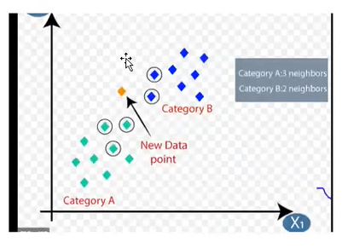

**Suppose P1 is the point, for which label needs to predict. First, you find the k closest point to P1 and then classify points by majority vote of its k neighbors. Each object votes for their class and the class with the most votes is taken as the prediction. For finding closest similar points, you find the distance between points using distance measures such as Euclidean distance, Hamming distance, Manhattan distance and Minkowski distance. KNN has the following basic steps:**

**1. Calculate distance**

**2. Find closest neighbors**

**3. Vote for labels**

**Notice in the image above that most of the time, similar data points are close to each other. The KNN algorithm hinges on this assumption being true enough for the algorithm to be useful. KNN captures the idea of similarity (sometimes called distance, proximity, or closeness) with some mathematics we might have learned in our childhood-calculating the distance between points on a graph.**

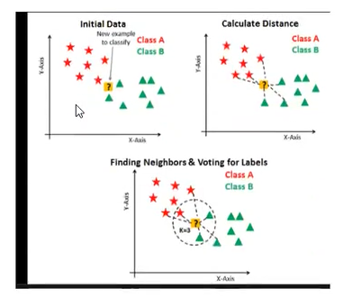

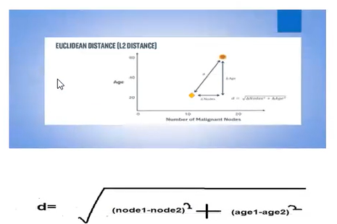

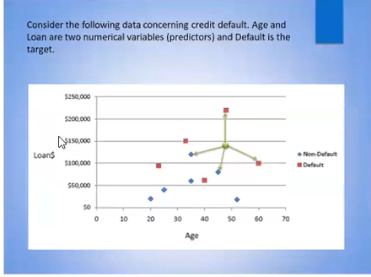

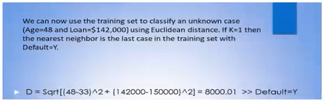

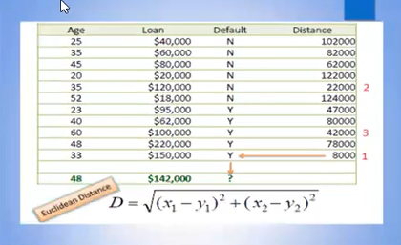

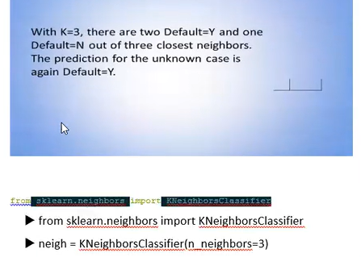

**Decision Tree Classifier**

We will discuss this classifier later.Although we use this classifier on 26th August python class and my Jupiter Notebook also you can check there.

**Support Vector Machine**

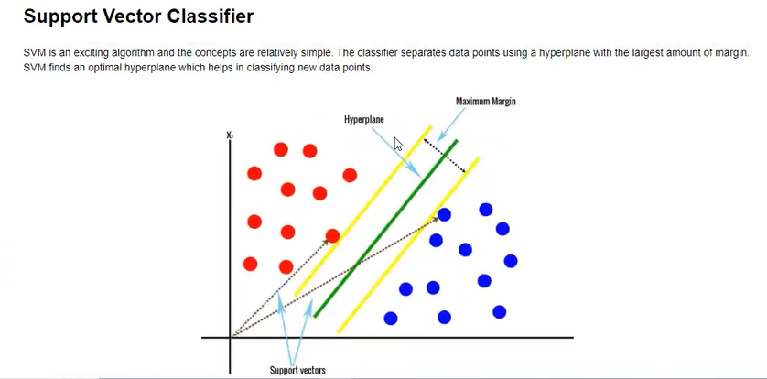

**Support Vectors**

Support vectors are the data points, which are closest to the hyperplane. These points will define the separating line better by calculating margins. These points are more relevant to the construction of the classifier.

**Hyperplane**

A hyperplane is a decision plane which separates between a set of objects having different class memberships.

**Margin**

A margin is a gap between the two lines on the closest class points. This is calculated as the perpendicular distance from the line to support vectors or closest points. If the margin is larger in between the classes, then it is considered a good margin, a smaller margin is a bad margin.